**COMPUTER VOICE AIDED LEARNING**

**BY**

**ELIJAH SALKUSHU**

**ST/CS/ND/19/412**

**A SEMINAR PRESENTATION TO THE DEPARTMENT OF COMPUTER SCIENCE, SCHOOL OF SCIENCE AND TECHNOLOGY FEDERAL POLYTECHNIC MUBI, ADAMAWA STATE NIGERIA IN PARTIAL FULFILLMENT OF THE REQUIREMENT FOR THE AWARD OF NATIONAL DIPLOMA(ND) IN COMPUTER SCIENCE**

**NOVEMBER, 2021**

***ABSTRACT***

*Voice-based web e-Education is a technology-supported learning paradigm that allows phone-access of learners to e-Learning web-based applications. These applications are designed mainly for the visually impaired. They are however lacking in attributes of adaptive and reusable learning objects, which are emerging requirements for applications in these domain. This paper presents a framework for developing intelligent voice-based applications in the context of e Education. The framework presented supports intelligent components such as adaptation and recommendation services.*

**Introduction**

According to Stephen Balashek, Biddulph, and Davis (March, 1952) Voice aided leaning is an interdisciplinary subfield of computer science and computational linguistics that develops methodologies and technologies that enable the recognition and translation of spoken language into text by computers. It is also known as automatic speech recognition (ASR), computer speech recognition or speech to text (STT).

It incorporates knowledge and research in the computer science, linguistics and computer engineering fields. Some speech recognition systems require "training" (also called "enrollment") where an individual speaker reads text or isolated vocabulary into the system. The system analyzes the person's specific voice and uses it to fine-tune the recognition of that person's speech, resulting in increased accuracy.

Systems that do not use training are called "speaker-independent" systems. Systems that use training are called "speaker dependent". Speech recognition applications include voice user interfaces such as voice dialing (e.g. "call home"), call routing (e.g. "I would like to make a collect call"), demotic appliance control, search key words (e.g. find a podcast where particular words were spoken), simple data entry (e.g., entering a credit card number), preparation of structured documents (e.g. a radiology report), determining speaker characteristics, speech-to-text processing (e.g., word processors or emails ), and aircraft (usually termed direct voice input).

**How to start voice typing**

According to a Zhao, Y (2003) describe how to use voice typing, you'll need to be connected to the internet, have a working microphone, and have your cursor in a text box. Once you turn on voice typing, it will start listening automatically. Wait for the "Listening..." alert before you start speaking. Action Do this Turn on voice typing Press Windows logo key + H on a hardware keyboard Press the microphone key next to the Spacebar on the touch keyboard To stop voice typing Say a voice typing command like "Stop listening" Press the microphone butt Install a voice typing language You can use a voice typing language that's different than the one you've chosen for Windows. Here's how:

1. Select Start > Settings > Time & language > Language & region.
2. Find preferred languages in the list and select add a language.
3. Search for the language you'd like to install, then select next.
4. Select next or install any optional language features you'd like to use. These features, including speech recognition, aren't required for voice typing to work. To see this feature's supported languages, see the list in this article.

**Switch voice typing languages**

According to Zhao, Y (2003) to switch voice typing languages, you'll need to change the input language you use. Here's how: Select the language switcher in the corner of your taskbar Press Windows logo key + Spacebar on a hardware keyboard Press the language switcher in the bottom right of the touch keyboard

**Supported languages**

According to Stephen Balashek, Biddulph, and Davis (March, 1952) these languages support voice typing in Windows 11:

1. Bulgarian
2. Chinese (Simplified, China)
3. Chinese (Traditional, Hong Kong SAR)
4. Chinese (Traditional, Taiwan)
5. Croatian
6. Czech
7. Danish
8. Dutch (Netherlands)
9. English (Australia)
10. English (Canada)
11. English (India)
12. English (New Zealand)
13. English (United Kingdom)
14. English (United States)
15. Estonian
16. Finnish
17. French (Canada)
18. French (France)
19. German
20. Gujarati
21. Hindi
22. Hungarian
23. Irish
24. Italian (Italy)
25. Japanese
26. Korean
27. Latvian
28. Lithuanian
29. Maltese
30. Marathi
31. Norwegian (Bokmål)
32. Polish
33. Portuguese (Brazil)
34. Portuguese (Portugal)
35. Romanian (Romania)
36. Russian
37. Slovak
38. Slovenian
39. Spanish (Mexico)
40. Spanish (Spain)
41. Swedish (Sweden)
42. Tamil (India)
43. Telugu
44. Thai
45. Turkish
46. Vietnamese
47. 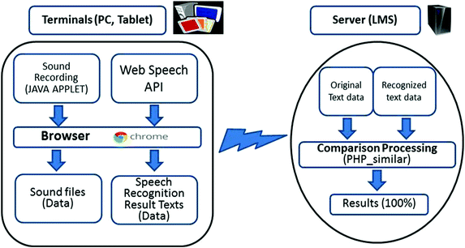

**Figure 1**

**Voice typing commands**

According to Levy, M., Stockwell (2006) Use voice typing commands to quickly edit text by saying things like "delete that" or "select that" The following list tells you what you can say. To view supported commands for other languages, change the dropdown to your desired language. Note: If a word or phrase is selected, speaking "delete that" will remove it.

**Type with your voice**

According to Zhao, Y (2003) you can type and edit by speaking in Google Docs or in Google Slides speaker notes. Tip: This feature is only available in Chrome browsers.

**Step 1**: Turn on your microphone to use voice typing or voice commands, your computer microphone needs to be on and working. Devices and microphones vary, so check your computer manual for instructions. Microphone settings are typically in the System Preferences on a Mac, or the Control Panel on a PC.

**Step 2:** Use voice typing Start voice typing in a document

1. Check that your microphone works.

2. Open a document in Google Docs with a Chrome browser.

3. Click Tools Voice typing. A microphone box appears.

4. When you're ready to speak, click the microphone.

5. Speak clearly, at a normal volume and pace (see below for more information on  
 using punctuation).

6. When you're done, click the microphone again.

**Start voice typing in Slides speaker notes**

1. Check that your microphone works.

2. Open a presentation in Google Slides with a Chrome browser.

3. Click Tools Voice type speaker notes. The speaker notes open, and a  
 microphone box appears.

4. When you're ready to speak, click the microphone.

5. Speak clearly, at a normal volume and pace (see below for more information on  
 using punctuation).

6. When you're done, click the microphone again.

**Correct mistakes while voice typing**

If you make a mistake while you're typing with your voice, you can move your cursor to the mistake and fix it without turning off the microphone. After you correct the mistake, move the cursor back to where you want to continue. To see a list of suggestions, right-click words underlined in gray.

**Architectural view**

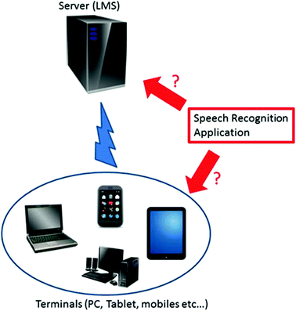

**Figure 2**

**Literature review**

1952 – Three Bell Labs researchers, Stephen Balashek, R. Biddulph, and K. H. Davis built a system called "Audrey" for single-speaker digit voice learning. Their system located the formants in the power spectrum of each utterance. Biddulph 1960 – Gunnar Fant developed and published the source-filter model of speech production. 1962 – IBM demonstrated its 16-word "Shoebox" machine's speech leaning capability at the 1962 World's Fair .1966 – Linear predictive coding (LPC), a speech coding method, was first proposed by Fumitada Itakura of Nagoya University and Shuzo Saito of Nippon Telegraph and Telephone (NTT), while working on speech leaning. Balashek 1969 – Funding at Bell Labs dried up for several years when, in 1969, the influential John Pierce wrote an open letter that was critical of and defunded voice aided leaning research.

**Conclusion**

This paper assumes the merits described in the previous section and attempts to enhance the quality of planning before posting. In so doing, this paper proposes a voice-blog system that enables learners to practice pronunciation before posting with the help of the (STT). Application. In the experiment that follows, we would like to show that the speaking proficiency improved with regards to fluency and accuracy.

**REFERENCE**

Bell Labs researchers, Stephen Balashek, R. Biddulph, and K. H. Davis (March,  
 1952) *USA*

Levy, M., Stockwell, G.: CALL Dimensions. Lawrence Erlbaum   
 Associates, Mahwah (2006) [*Google Scholar*](http://scholar.google.com/scholar_lookup?title=CALL%20Dimensions&author=M.%20Levy&author=G.%20Stockwell&publication_year=2006)

Zhao, Y.: Recent developments in technology and language learning: a steps for  
 voice leaning. And meta-analysis. Japan CALICO J. **21**(1), 7–27 (2003)  
 [*Google Scholar*](http://scholar.google.com/scholar_lookup?title=Recent%20developments%20in%20technology%20and%20language%20learning%3A%20a%20literature%20review%20and%20meta-analysis&author=Y.%20Zhao&journal=CALICO%20J.&volume=21&issue=1&pages=7-27&publication_year=2003)*.*

Hirotani, M.: Synchronous versus asynchronous CMC and transfer to  
 Japanese oral performance. CALICO J. **26**(2), 413–438 (2003)[*Google  
 Scholar*](http://scholar.google.com/scholar_lookup?title=Synchronous%20versus%20asynchronous%20CMC%20and%20transfer%20to%20Japanese%20oral%20performance&author=M.%20Hirotani&journal=CALICO%20J.&volume=26&issue=2&pages=413-438&publication_year=2003)*.*